

Master of Computer Applications
Semester – III
Data Analytics for Business
Experiment No.: 9

Title: Exploratory data analysis on business datasets

Submitted By:
Name: A.Deepak
Reg. No.: 2511022250001
Date: 30/08/2026

Submitted To:
Faculty Name: Mr. Aman Kumar Sharma

Department of Computer Application
Alliance University
Chandapura - Anekal Main Road, Anekal
Bengaluru – 562106

Experiment No.: 9
Exploratory data analysis on business datasets

Problem Statement
You are a Data Analyst at a consulting firm. A client has provided a large business dataset and wants to understand key trends and patterns. Perform exploratory data analysis (EDA) to uncover meaningful business insights and identify opportunities for improvement.

Introduction
Exploratory Data Analysis (EDA) is the process of examining and understanding a dataset using statistical methods, data visualization, and analytical techniques. It helps identify patterns, relationships, trends, and unusual observations before performing advanced analysis.
In this experiment, a synthetic dataset containing 500 student records was analyzed using Power BI. The dataset contains information about students' study habits, attendance, coding practice, assignment completion, learning platforms, AI tool usage, mock tests, and performance scores.
An interactive one-page dashboard was developed to present the important findings in a simple and professional format. The dashboard uses KPI cards, charts, and slicers to help users explore student learning patterns and their relationship with academic performance.

Objectives
The main objectives of this experiment are:
- To understand the structure of a student learning dataset.
- To analyze student learning behavior.
- To calculate important performance indicators.
- To examine relationships between learning activities and performance.
- To compare student performance across academic years.
- To analyze the usage of different learning platforms.
- To identify different student performance segments.
- To create meaningful data visualizations.
- To develop an interactive Power BI dashboard.
- To derive useful insights from the analyzed data.

Methodology / Steps Followed
The project was implemented using Microsoft Power BI. The major steps followed were:
- Dataset Import
- Data Cleaning and Transformation
- Data Type Validation
- DAX Measure Creation
- KPI Creation
- Dashboard Development
- Interactive Filtering
- Data Visualization
- Insight Generation
Step 1: Dataset Import
The synthetic student dataset was imported into Power BI Desktop using the Text/CSV connector.
The process involved:
- Opening Power BI Desktop.
- Selecting Get Data.
- Selecting Text/CSV.
- Selecting the student dataset.
- Previewing the data.
- Loading the dataset into Power BI.
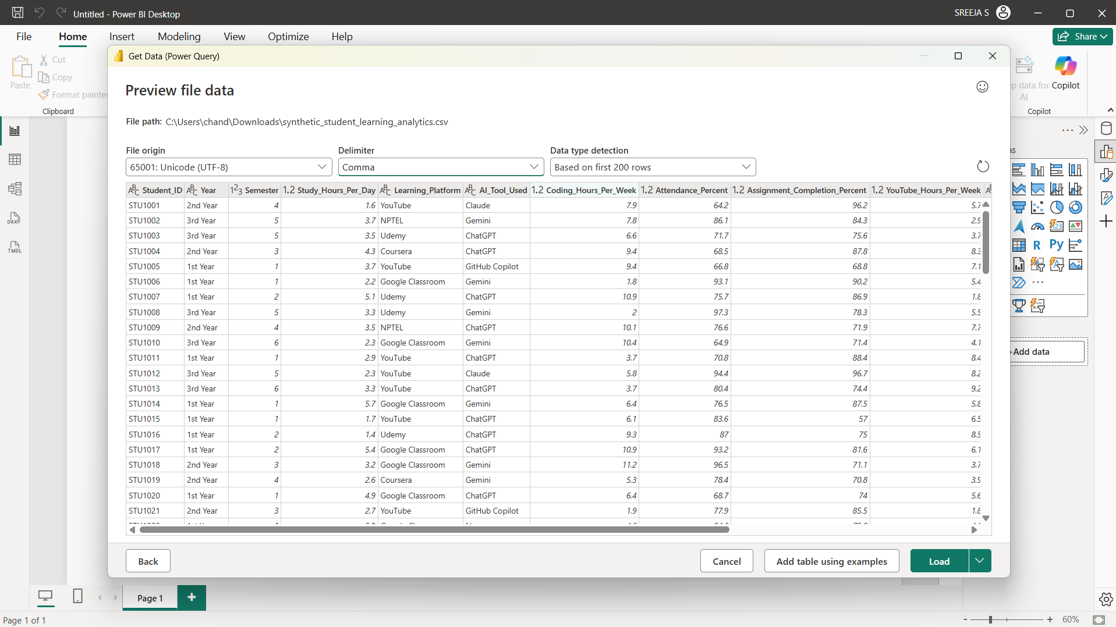
Step 2: Data Cleaning and Transformation
The dataset was checked to make sure that the data was suitable for analysis.
The following were checked:
- Column names
- Missing values
- Data types
- Numerical fields
- Categorical fields
- Student performance values
The data was prepared before creating the dashboard.
Step 3: Data Type Validation
The important columns were assigned appropriate data types.
Column | Data Type
Student_ID | Text
Year | Text
Semester | Whole Number
Study_Hours_Per_Day | Decimal Number
Learning_Platform | Text
AI_Tool_Used | Text
Coding_Hours_Per_Week | Decimal Number
Attendance_Percent | Decimal Number
Assignment_Completion_Percent | Decimal Number
YouTube_Hours_Per_Week | Decimal Number
Group_Study | Text
Mock_Tests_Per_Month | Whole Number
Performance_Score | Decimal Number
Student_Segment | Text

Step 4: DAX Measure Creation
DAX measures were created to calculate important student performance indicators.
Total Students
Total Students =
DISTINCTCOUNT(Student_Data[Student_ID])
Average Performance
Average Performance =
AVERAGE(Student_Data[Performance_Score])
Average Attendance
Average Attendance =
AVERAGE(Student_Data[Attendance_Percent])
Average Study Hours
Average Study Hours =
AVERAGE(Student_Data[Study_Hours_Per_Day])
Average Coding Hours
Average Coding Hours =
AVERAGE(Student_Data[Coding_Hours_Per_Week])
Step 5: KPI Creation
Five KPI cards were created:
- Total Students
- Average Performance
- Average Attendance
- Average Study Hours
- Average Coding Hours
These KPIs provide a quick overview of student learning and performance.
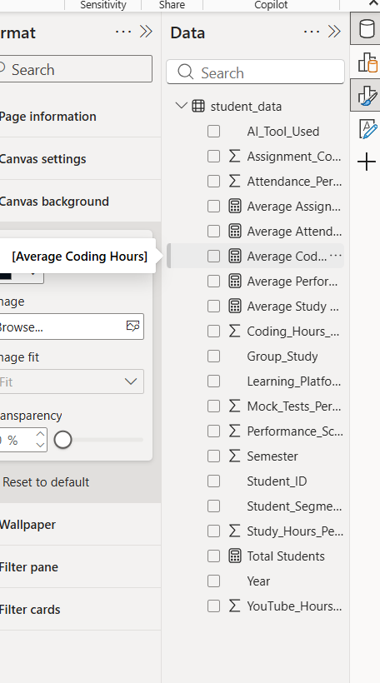
Step 6: Dashboard Development
A professional one-page Student Learning Analytics Dashboard was developed using Power BI.
The dashboard contains:
- KPI cards
- Interactive slicers
- Performance analysis
- Study analysis
- Attendance analysis
- Learning platform analysis
- Student segment analysis

Step 7: Interactive Filters
The following slicers were added:
- Year
- Semester
- Learning Platform
- Student Segment
These filters allow users to analyze specific groups of students.
Step 8: Data Visualization
Six important charts were created.
8.1 Average Performance by Year
Chart: Clustered Column Chart
- Axis: Year
- Value: Average Performance
This chart compares student performance across different academic years.
8.2 Study Hours vs Performance
Chart: Scatter Chart
- X-axis: Study Hours Per Day
- Y-axis: Performance Score
- Details: Student ID
- Legend: Student Segment
This chart shows the relationship between study time and performance.
8.3 Attendance vs Performance
Chart: Scatter Chart
- X-axis: Attendance Percentage
- Y-axis: Performance Score
- Details: Student ID
This helps analyze the relationship between attendance and performance.

8.4 Student Performance Segments
Chart: Donut Chart
- Legend: Student Segment
- Values: Total Students
The students are divided into:
- High Performer
- Average Performer
- Needs Improvement
8.5 Students by Learning Platform
Chart: Bar Chart
- Axis: Learning Platform
- Value: Total Students
This shows the most commonly used learning platforms.
8.6 Coding Practice and Performance by Year
Chart: Combo Chart
- Axis: Year
- Column: Average Coding Hours
- Line: Average Performance
This compares coding practice and performance across academic years.
Step 9: Dashboard Design
A professional dark theme was used for the dashboard.
The design includes:
- Dark background
- Professional header
- KPI cards
- Blue and teal accents
- Clear chart titles
- Interactive slicers
- Consistent layout
The one-page dashboard provides a simple overview of student learning behavior and performance.
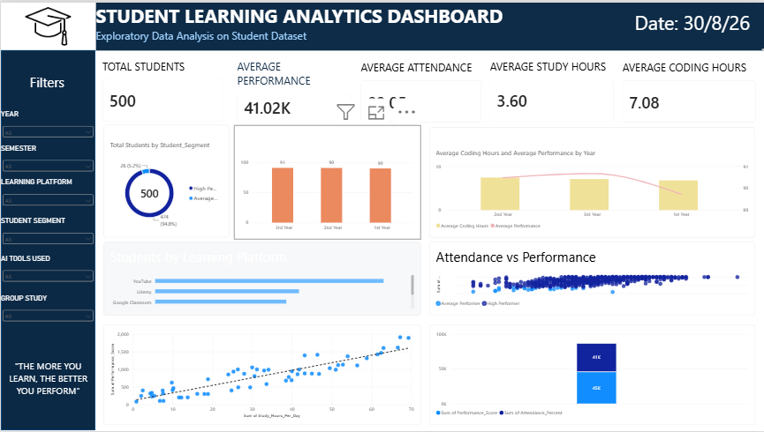
Business Questions Answered
The dashboard helps answer:
- How many students are included in the dataset?
- What is the average student performance?
- What is the average attendance?
- How many hours do students study?
- Which year has better performance?
- Is study time related to performance?
- Is attendance related to performance?
- Which learning platform is most popular?
- What percentage of students are high performers?
- How does coding practice vary across years?

Key Insights
The dashboard can be used to identify:
- Differences in performance between academic years.
- Relationship between study hours and performance.
- Relationship between attendance and performance.
- Most commonly used learning platforms.
- Distribution of high, average, and low-performing students.
- Differences in coding practice between academic years.
Conclusion
The Student Learning Analytics Dashboard demonstrates how Power BI can be used to explore and understand student data.
The dataset was imported, prepared, and analyzed using DAX measures and visualizations. KPI cards were used to show important student statistics, while charts were used to analyze performance, study hours, attendance, learning platforms, and coding practice.
Interactive slicers allow users to filter the dashboard and analyze different student groups. The final dashboard provides a simple and professional view of student learning patterns and performance.
Learning Outcomes
Through this experiment, the following skills were developed:
- Power BI data import
- Data cleaning
- Data type validation
- DAX measure creation
- KPI creation
- Data visualization
- EDA
- Student performance analysis
- Interactive slicers
- Dashboard design
- Insight generation
- Data-driven decision-making
GitHub Repository Link:
https://github.com/deepakMudiraj06/Power-BI
GitHub Project Folder Link:
https://github.com/deepakMudiraj06/Power-BI/tree/main/Assignment%209

